**Great tools you can use for your Agile Projects**

Here is a list of great tools which you can use for your Agile projects. Many of them are completely free! Click on the image and you will be taken to each tool.

**Jira**

[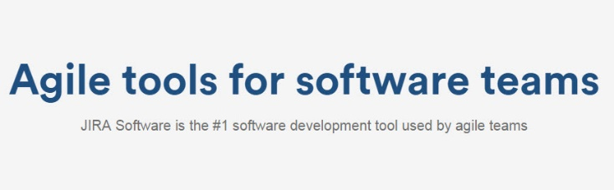](https://www.atlassian.com/software/jira/agile)

**Trello**

[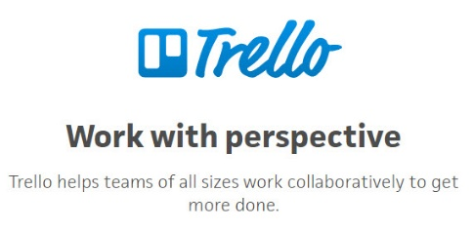](https://trello.com/)

**Freedcamp**

[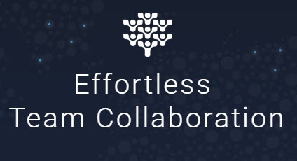](https://freedcamp.com/)

**Asana**

[](https://asana.com/)

**Basecamp**

[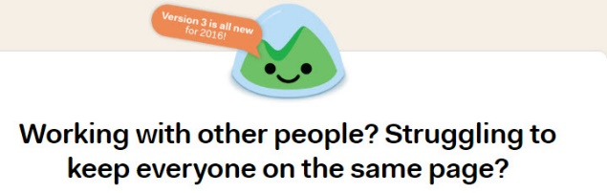](https://basecamp.com/)

**Active Collab**

[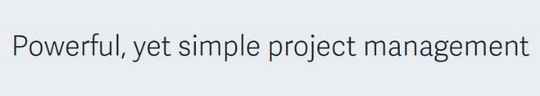](https://www.activecollab.com/)

**Workamajig**

[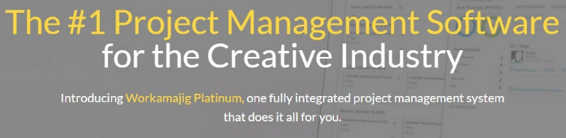](https://www.workamajig.com/)

#### Teams

#### [https://udemy-images.s3.amazonaws.com/redactor/raw/2018-07-02_22-48-39-af3f7a36e09a6b2d9d21fe887b2295ec.PNG](https://products.office.com/en-au/microsoft-teams/group-chat-software)​

#### ​

#### Planner​

[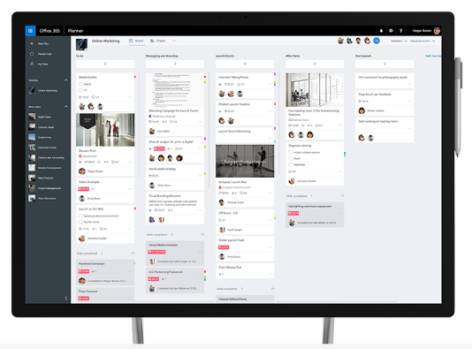](https://products.office.com/en-au/business/task-management-software)​